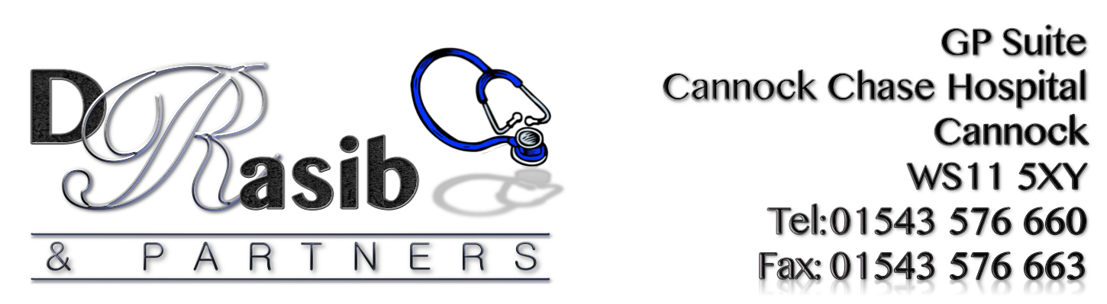

P.R.G. MEETING

Date: Tuesday 15th December 2015 @ 1.00pm
Location: GP Suite Cannock Chase Hospital.

Minutes of Meeting

1. Persons Present
Sam Rasib. David Stagg. Patrick Pincomb. Sarah Giles.
Barbara Cooper. Lilian Hyde. Geoff Hacket. Pamela Burlingham
Janice Lloyd.

2. Apologies.
Elizabeth Chapman.

3. Minutes of previous meeting held 6.10.15.
David read the minutes of the last meeting. Minutes passed and agreed.

4. Matters Arising.
Lilian apologised for missing previous meetings and thanked the group for their support over the past weeks.

5. Managers Report.
Sam stated the Network Group was doing well. The function of the Network Clinic was explained briefly again as to how it worked.
Julie Chamberlain has now left the Surgery.
Sam talked about a new service (Ultrasound scanning) being available at the Surgery (initially on a fortnightly basis) commencing Friday 17th December. This ultrasound service will perform scans to cover the following areas:

- General
- Renal
- Gynaecology
- Musculoskeletal & Interventional MSK
- Vascular

There will be timely access available (normally within five days in most cases) and reports will normally be accessible to the GP the next day (same day for Urgent cases).

6.Collating.
There were 371 questionnaires filled in 47 E Mail addresses were given and 54 comments made. Questions 8-14 need to be re-collated. Results will be handed in to Sam the second week of February. This will be re-collated on Mon 18th and Tue 19th January.

6. Any Other Business.
It was stated that there had been recent problems with the computers going down, this caused a few problems for receptionists not knowing who had appointments etc. At present lists of appointments are run of at the end of the day showing appointments booked for the next day. However, due to a same day appointment booking system, it was suggested that all appointments should be run off lunchtime to cover evening appointments and last thing at night for morning appointments.
It was bought to our attention that when the answer phone comes on to say receptionists are busy from a BT line this costs patients 21p per call. Therefore, Sam shall liaise with the hospital to see what other options are available to avoid any cost being incurred to the patients.
David is going to contact Rugeley to arrange a Dementia presentation meeting.
Sam is going to contact CCG with regards to disposal of Sharp
Boxes.
A Vice Chairman and Secretary positions need to be resolved at the next meeting.
As from January 2016 the group will be known as PPG. Patient Participation Group.

Next Meeting Tuesday February 16th at 1.00pm

